Task 5 Comparing the Physical Properties of Sucrose and Sodium Chloride
Name: /25
Materials:
- Sucrose (C₁₂H₂₂O₁₁) | - Electrode | - Power pack
- Sodium chloride | - Bunsen burner | - Electrical leads
- Distilled water | - Crucible
- 100 mL beaker | - Stirring rod
- Bench mat | - Globe

Method:
Part 1 – Electrical Conductivity
- Rinse and then fill a 100 mL beaker with 75 mL of distilled water.
- Pour 5 grams of sucrose into the water, and stir with a stirring rod until dissolved.
- Place the electrode kit in the beaker and set up the circuit shown in Figure 1.
- Turn the power pack on at 8V. Record any observations.
- Rinse and refill the 100 mL beaker with distilled water. Repeat steps 2-4 with sodium chloride.
- Repeat the experiment using a solid sample of each compound. Record any observations.
Part 2 – Melting Point
- Add 1 g of sucrose to a crucible, enough cover the bottom with a single layer.
- Place the crucible on a gauze mat sitting on a tripod.
- Light the Bunsen burner and adjust the level of oxygen to produce the hot, non-luminous flame.
- Move the tripod so that the crucible sits over the flame.
- Carefully observe contents of the crucible.
- Extinguish the Bunsen burner if you observe the contents of the crucible start to melt.
- Extinguish the Bunsen burner if you do NOT observe a change within 1 minute.
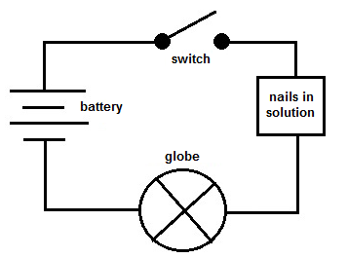
- Allow the crucible and contented to cool while writing down any observations.
- Repeat steps 1-6 with sodium chloride.

Figure 1: Circuit diagram to set up in order to test the
electrical conductivity of the two solutions.

Questions:
- What is the independent variable?
________________________________________________________________________________
(1 mark)
- What is the dependent variable for each part?
________________________________________________________________________________
________________________________________________________________________________
(2 marks)
- What is one controlled variable for each part?
________________________________________________________________________________
________________________________________________________________________________
(2 marks)
- In the space below, draw up a table of results.
(6 marks)

- Complete the table for the two substances tested, and predict the properties of the other substances listed.
(6 marks)

Substance | Chemical Formula | Bonding Present  ionic/covalent | Melting Point  low/high | Conduct Electricity when solid? | Conduct electricity when aqueous?
Table Salt
Sucrose | C₁₂H₂₂O₁₁
Carbon dioxide
Copper(II) sulfate
Iron(II) oxide

- Use your knowledge of bonding types to compare the differences in electrical conductivity between sucrose and sodium chloride.
(4 marks)

- Use your knowledge of bonding types to compare the differences in melting point between sucrose and sodium chloride.
(4 marks)

